# PIZZA SALES SQL QUERIES

### Total revenue:

The sum of the total price of all pizza ordered.

SELECT SUM(total_price) AS Total_Revenue FROM pizza_sales

Output:

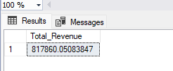

## Average order value

SELECT SUM(total_price) / COUNT(DISTINCT order_id) AS avg_order_value FROM pizza_sales

Output:

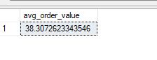

### Total Pizza Sold

SELECT SUM(quantity) AS total_pizza_sold FROM pizza_sales

Output:

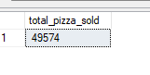

### Total Orders

SELECT COUNT( DISTINCT order_id) AS total_order FROM pizza_sales

Output:

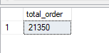

### Average Pizza per order

SELECT CAST(CAST(SUM(quantity) AS decimal(10,2)) / CAST(COUNT( DISTINCT order_id) AS decimal (10,2)) AS DECIMAL(10,2)) AS avg_pizza_per_order FROM pizza_sales

Output:

